JESUS – THE SUFFERING SERVANT

MARK15:22-39 |12 FEBRUARY 2012

2ND STREET COMMUNITY CHURCH

GREGG LAMM, LEAD PASTOR-TEACHER
www.2ndstreet.org

It’s good to be with you … to worship God, and to seek His words, His plans, and His purposes for our lives, and to ask Him to open the eyes of our hearts to know how He wants the Gospel to come alive in us AND be poured out of us into the world.

As we come near the end of The Gospel of Mark, we’ve seen Jesus arrested, tried, and beaten. When we left this story last Sunday Jesus had fallen under the weight of His cross – and it was being carried the rest of the way to Calvary by a Jewish man from North Africa named Simon, who was probably visiting Jerusalem to celebrate Passover. And now Jesus, Simon, and the entourage traveling with Him have arrived at their destination of Calvary.

This morning we come to Jesus Christ’s crucifixion – the singular event that splits all of human history in two, … as His death paid the price God required for the sins of the world to be forgiven … the price required by God so that you and I, by confessing our sins to God and receiving His forgiveness, could come back into relationship with God and begin the journey of being His follower – a Christian, a follower of Jesus Christ … people who are inviting God to teach us, day-by-day a whole new way to be human. I originally thought that we’d go through MARK 15:22-47 this morning … but we’re going through MARK 15:22-39.

MARK 15:22 (NEW AMERICAN STANDARD BIBLE)

²² Then they brought Him [Jesus Christ] to the place Golgotha, which is translated, Place of a Skull. [emphasis added]

Jesus’ physical condition is declining rapidly. When Jesus left His trial with Pilate, He was walking and the soldiers were leading Him. But now that Jesus is nearing Calvary, He barely walk, and He has to be brought to Golgotha. The Greek word Mark uses for brought is perousin (φέρουσιν), which means to carry, or to bear.

Calvary isn’t a place like Tolkien’s Middle Earth … a made-up place to describe a made-up story. Calvary was a real, very specific, location outside the Northern city walls of Jerusalem – a location where people condemned by Rome to die were crucified. And so as a place of execution, you can see why it was also called Golgotha, meaning the Place of a Skull. But one of the two main locations modern-day archeologists believe could be Golgotha, actually looks, especially from a distance, like a human skull.

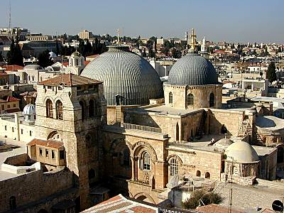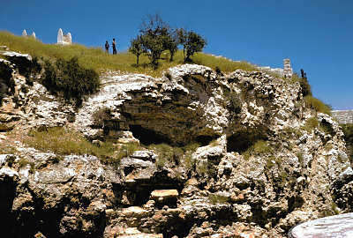

The Church of the Gordon’s Calvary
Holy Sepulcher

If you go to Jerusalem today you’ll find The Church of the Holy Sepulcher built in the 4th-Century by Emperor Constantine’s Christian mother the Empress Helena, on the site believed by many to be Golgotha. The Church of the Holy Sepulcher is owned by the Greek Orthodox Church and of course, is a huge tourist attraction. In 1882, General Charles Gordon, a well-known British military man and self-credentialed archeologist, identified a different location just North of Jerusalem as the Golgotha site – and it’s a site that some Biblical archeologists still today believe is the correct location. It has a Muslim cemetery on top, but below is a stone outcropping that looks remarkably like a skull and is also close to many ancient Jewish tombs.

MARK 15:23 (NEW AMERICAN STANDARD BIBLE)

²³ They [the Roman soliders] tried to give Him [Jesus Christ] wine mixed with myrrh; but He did not take it. [emphasis added]

1st-Century Jewish historian Josephus tells us that wine was often mixed with myrrh to make it taste better, and that this combination had a narcotic effect to help deaden pain. According to a rabbinic tradition referenced in PROVERBS 31:6-7 sedative drinks like this were offered to crucified prisoners as a final act of mercy.

But Mark tells us here in v. 23 that Jesus refused to drink anything that would numb the pain of what He was experiencing in His death … but that He was choosing to face the agony of the cross with a clear mind. I love the words 19th-Century British pastor, teacher, author and theologian Charles Spurgeon shares with us about this …

“It was not out of any love of suffering that Jesus refused the wine-cup. Christ had no love of suffering. He had a love of souls …”

MARK 15:24 (NEW AMERICAN STANDARD BIBLE)

²⁴ And they crucified Him, and divided up His garments among themselves, casting lots for them to decide what each man should take.

Frankly, Jesus didn’t have all that much left to fight over; especially now that He was either naked, or just wearing a loincloth. But nonetheless, it was the custom for executioners to divide up prisoner’s belongings. PSALM 22 was written about 1,000 B.C., and the Romans began using crucifixion about 900 years later, around 90 B.C. … and so, without even realizing it, as the soldiers threw dice to see would end up with Jesus’ cast-off, blood-soaked garments, they were fulfilling one of the over 300 prophecies concerning the death of the Messiah recorded in The Old Testament.

Listen to how King David prophetically describes what Jesus Christ would feel and experience during His crucifixion … 1,033 years after his words were written …

PSALM 22:14-18 (NEW AMERICAN STANDARD BIBLE)

¹⁴ I am poured out like water, and all My bones are out of joint; My heart is like wax; it is melted within Me.
¹⁵ My strength is dried up like a potsherd, and My tongue cleaves to My jaws; and you lay Me in the dust of death.
¹⁶ For dogs have surrounded Me; a band of evildoers has encompassed Me; they pierced My hands and My feet.
¹⁷ I can count all My bones. They look, they stare at Me;
¹⁸ They divide My garments among them, and for My clothing they cast lots.

Clothing is one of the many things that distinguishes one culture from another. When you’re in Japan you see Kimonos, but when you’re in Moscow, not so much. When you’re in Arabia you see veils covering women’s faces, but when you’re in Gaston, Oregon not so much. When you’re on Waikiki Beach, Hawaii you see flip-flop sandals, but when you’re at the Arctic Circle, not so much.

But gang, I believe once Jesus was stripped of every article of His clothing and once He was nailed to the Cross of Calvary, He showed us that He was shedding every identifying mark of any single culture and becoming the Savior who would take away the sin of the whole world (JOHN 1:29) and not just the sin of CERTAIN PEOPLE in the world. And it’s here that I see our FIRST FAITH LESSON this morning …

FAITH LESSON 1

Because God loves ALL PEOPLE, and wants EVERYONE to come into relationship with Him, Jesus Christ died on the cross for EVERYONE.

And friends, this reality must INFORM and MOTIVATE the hearts, minds, passions, priorities, and the thoughts, words, and deeds of all maturing followers of Christ.

MARK 15:25 (NEW AMERICAN STANDARD BIBLE)

²⁵ It was the third hour when they crucified Him.

Rome didn’t invent crucifixion, but they perfected it as a mixture of torture and execution. Experts in anatomy and physiology, and engineers tell us that when the 300something pound cross was lifted up and dropped several feet down into the hole that was dug to hold it, that literally multiple tons of pressure were put onto the body of the person nailed to the cross. And that in fact, when the bottom of the cross landed in its resting place, both shoulders and elbows of the person nailed to the cross dislocated and each arm became roughly six inches longer.

Mark doesn’t tell us all the specific details of HOW JESUS CHRIST WAS CRUCIFIED … because his original readers were familiar with crucifixion and didn’t need such details. But the other three Gospel accounts give us more details (MATTHEW 27; LUKE 23; JOHN 19), and here’s a summary of what we know about crucifixion from the Bible, and from Roman and Jewish writings and artwork …

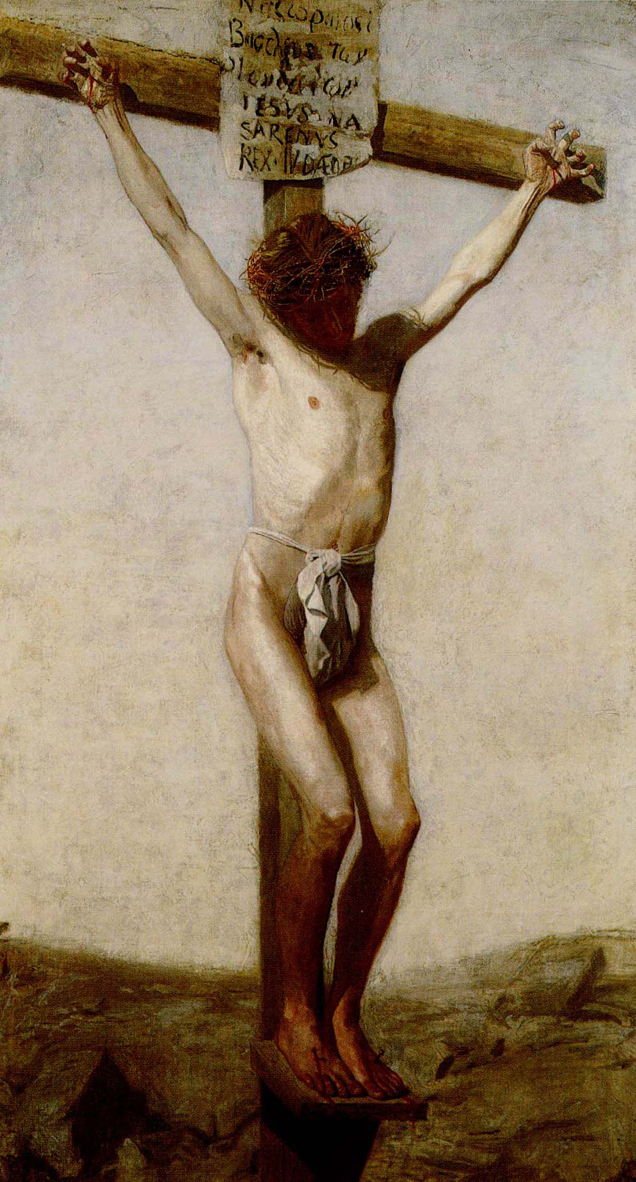

- Prisoners’ back was torn open by scourging, then the clotting blood on their backs was ripped open again when their clothes were torn off.
- Prisoners were crucified naked or in a loincloth.

Jesus Christ chose to die on the cross for you and for me.

- When prisoners were thrown to the ground to fix their hands to the crossbeam, their wounds were torn open again and contaminated with dirt.
- The prisoner’s first hand was nailed to the cross – not through the palm, but through the strong ligaments in the carpal area where the wrist flexes. Then the prisoner’s other hand was stretched tight so that the arms were straight across. Sometimes their arms were also tied with ropes at the wrist to the cross.
Jesus Christ chose to die on the cross for you and for me.

- When the nail was driven through their wrists, it severed the large median nerve going to the hand. This stimulated nerve produced excruciating pain in both arms, and most often resulted in a claw-like grip in the victim’s hands.
- The prisoner’s knees were bent and their feet were then nailed flat to the cross.

Jesus Christ chose to die on the cross for you and for me.

- The physics of crucifixion made it excruciatingly painful to simply breathe. The weight of the prisoner’s body pulling down on the arms and shoulders made it feel like they could inhale, but not exhale.
- The lack of oxygen led to severe muscle cramps, which made it even harder to breathe.

Jesus Christ chose to die on the cross for you and for me.

- To get a good breath, the prisoner had to push against their feet and flex their elbows, pulling from their shoulders.
- Putting the weight of their body on their nail-pierced feet produced searing pain, and flexing their elbows twisted the prisoner’s wrists which were hanging on the nails.

Jesus Christ chose to die on the cross for you and for me.

- Lack of oxygen raised the prisoner’s carbon dioxide levels in the blood, which makes them struggle to breathe, and their heart began beating as fast as possible to oxygenate their blood. Instead of pumping its normal 5 liters of blood per minute, after being nailed to the cross, the prisoner’s heart was soon pumping 20 liters of blood per minute.
- As the prisoner experiences high output failure, their blood pressure becomes so high that plasma was actually forced out the walls of their blood vessels into the area between the thorax and the lung. This fluid lost from the blood and filling this area could amount to a gallon, and the only way for the body to replace it was to drink liquids. This is why near His death Jesus cried out, “I am thirsty” (JOHN 19:28)

Jesus Christ chose to die on the cross for you and for me.

- As prisoner’s hung on their cross, each breath they took made the painful wounds on their back scrape against the rough wood of the cross’s upright beam.
- Each effort to get a proper breath was agonizing, exhausting, and led to a quicker death, as the prisoner literally suffocated to death.

Jesus Christ chose to die on the cross for you and for me.
I believe that Mark doesn’t give us an actual, detailed description of the act of crucifixion because instead of only wanting to AROUSE OUR FEELINGS by telling us what happened at the crucifixion, God the Father wants the crucifixion to AFFIRM OUR FAITH. And it’s here that I see our SECOND FAITH LESSON this morning …

FAITH LESSON 2

Seeing the crucifixion, and the kind of sacrifice God requires for the forgiveness of sin, maturing followers of Jesus Christ realize how HEINOUS EACH ACT OF SIN IS IN GOD’S SIGHT.

ACTION STEP … Take the ¼ sheet of paper you were given when you came in and sat down, and on one side of it write out the name of a sin you’ve been holding onto, either because …

- You didn’t want to stop committing it … or …
- You didn’t think you could stop committing it … or …
- You think that if you asked for forgiveness, God would laugh and say something like, “You’ve got to be kidding! No way am I going to forgive you of that!” … or …
- You didn’t think you deserved to be forgiven for it …

Now turn that piece of paper over and hold onto it for a bit.

After hearing these details of the crucifixion, it’s amazing to note that Jesus Christ, knowing what death on the cross would be like, had the verses from PSALM 22 that we looked at earlier written and put into the Bible. Here are some more of King David’s words from PSALM 22, written over 1,000 earlier earlier, again, speaking prophetically about Jesus Christ’s crucifixion …

PSALM 22:1, 6-8 (NEW AMERICAN STANDARD BIBLE)

¹ My God, my God, why have You forsaken me? Far from my deliverance are the words of my groaning.
⁶ But I am a worm and not a man, a reproach of men and despised by the people.
⁷ All who see me sneer at me; they separate with the lip, they wag the head, saying,
⁸ “Commit yourself to the LORD; let Him deliver him; Let Him rescue him, because He delights in him."

Okay, now back to MARK 15 … v. 26 …

MARK 15:26 (NEW AMERICAN STANDARD BIBLE)

²⁶ The inscription of the charge against Him read, “THE KING OF THE JEWS.”

Mark abbreviates the inscription nailed to the head of the cross, but John tells us exactly what was written, “JESUS THE NAZARENE, THE KING OF THE JEWS.” (JOHN 19:19-22).

MARK 15:27-28 (NEW AMERICAN STANDARD BIBLE)

²⁷ They crucified two robbers with Him, one on His right and one on His left.
²⁸ [And ISAIAH 53:12 was fulfilled which says, “And He was numbered with transgressors.”]

And when I ponder the words on this sign, and the two thieves crucified on either side of Jesus, I think about the words of American Bible Scholar Warren Wiersbe in his commentary on The Gospel of Mark entitled Be Diligent … and I relate to the truth they call me to … about Jesus and about myself …

“It may be that the message of this sign first aroused the hopes of the repentant thief. He may have reasoned: ‘If His name is Jesus, He’s a Savior. If He’s from Nazareth, He can identify with rejected people. If He has a kingdom, maybe there’s room for me!”

Mark tell us that Jesus’ crucifixion between the two robbers was a fulfillment of prophecy found in ISAIAH 53:12. And yet the reality is that it’s people just like those two robbers that Jesus was dying for … people just like you and me. Can you picture Jesus dying for someone like you, but not for people you believe are DIFFERENT THAN YOU, or that you’ve labeled as being WORSE THAN YOU, or not AS DESERVING AS YOU?

Oh friends, if I just described you, or how you look at the cross of Jesus Christ, then I’m glad you’re here this morning because I believe that God wants to open your eyes to a whole new truth … and that is that there’s nothing any of us can do to make God love us more. And there’s nothing any of us can do that will make God love us any less. God loves us. Period.

And it’s this pure, permanent and holy love that drove God to make a final and lasting way for people, ALL PEOPLE, people from every corner of the world, people like you and people like me, and people not like me and people not like you … it’s GOD’S LOVE FOR ALL PEOPLE that drove Him to make a final and lasting way for all of us to be able to be forgiven of our sins and come into relationship with Him. Here’s a drama that speaks into what I’m talking about here …

DRAMA … “THE UNTOUCHABLES”

We’re going to read through these last eleven verses quickly, and I’ll just share a few comments with you on them – not because they’re not important, but because the cross is the central fixture of this passage, not all the other supporting information. If you’d like to read more details of these final moments on the cross, go to the BIBLE TEACHING section of the 2nd Street website (www.2ndstreet.org) and download the three manuscripts or the audio files of the teachings I did on JOHN 19.
MARK 15:29-32 (NEW AMERICAN STANDARD BIBLE)

²⁹ Those passing by were hurling abuse at Him, wagging their heads, and saying, “Ha! You who are going to destroy the temple and rebuild it in three days,
³⁰ save Yourself, and come down from the cross!”
³¹ In the same way the Chief Priests also, along with the Scribes, were mocking Him among themselves and saying, “He saved others; He cannot save Himself.
³² Let this Christ, the King of Israel, now come down from the cross, so that we may see and believe!” Those who were crucified with Him were also insulting Him.

As Jesus hung on the cross, the verbal abuse, the mocking, and the insults continued to come from the Jews, the Chief Priests, by the Scribes, and even by one of the thieves Jesus was being crucified with. At that point, I would have definitely had enough. I would have called the whole thing off, done what the Chief Priests and the Scribes suggested, and smoked every human on earth with lightning bolts. Aren’t you glad that it was Jesus Christ, the Son of God, who died on the cross for your sins, and not just another human being, like you or like me?

And I see Jesus’ love and patience, and His willingness to go through each part of this horrific crucifixion as more evidence of just how deep and real His love for the whole world, for you and me, really is. In fact, LUKE 23:39-43 tells us that one of the criminals Jesus was crucified with came to faith in Jesus during his crucifixion. Gang, listen to me, it’s never too late for a heart to turn to Jesus Christ, and come home to God. Never. Never. Amazing.

Again, many of these things Mark, Luke, Matthew, and John tell us about the crucifixion in the four Gospels are also fulfillments of Old Testament prophecies that had been made about the Messiah and His death, or that Jesus Himself had prophetically spoken of during His three years of life and ministry on the earth … and in fact, we’re told in ACTS 6:7 that a great many priests also became believers, and I know that it was seeing with their own eyes all these prophecies being fulfilled in the crucifixion and the death of Jesus Christ, that brought them to surrender to God, and to faith in Jesus Christ as “the way, the truth, and the life.” (JOHN 14:6). And now in vv. 33-36 we come to the last words of Jesus Christ …

MARK 15:33-36 (NEW AMERICAN STANDARD BIBLE)

³³ When the sixth hour came, darkness fell over the whole land until the ninth hour.
³⁴ At the ninth hour Jesus cried out with a loud voice, “ELOI, ELOI, LAMA SABACHTHANI?” which is translated, “MY GOD, MY GOD, WHY HAVE YOU FORSAKEN ME?”
³⁵ When some of the bystanders heard it, they began saying, “Behold, He is calling for Elijah.”
³⁶ Someone ran and filled a sponge with sour wine, put it on a reed, and gave Him a drink, saying, “Let us see whether Elijah will come to take Him down.”

Luke tells us in LUKE 23:45 that even though it was daytime, there was a solar eclipse, as Jesus died and the light of the world (JOHN 8:12) was snuffed out. The Passover was always held during a full moon, a time when a natural eclipse of the sun would be impossible. And Mark makes it clear in v. 33 that this darkness lasted for three hours. Even the heavens were mourning the death of Jesus Christ, their Creator God. Do you see it? For all eternity past, Jesus had never known separation from God the Father. But now He does. And the Apostle Paul describes for us what was happening in his second letter to the Christ-followers living in the Corinth …

SECOND CORINTHIANS 5:19-21 (PARAPHRASE)

¹⁹⁻²¹ God was in Christ, making it possible for the world to be able to come back into relationships with Himself … through Christ’s death on the cross, no longer counting people’s sins against them … we speak for Christ when we plead, “Come back to God!” For on the cross, God made Christ, who never sinned, to be the offering for your sin and my sin, so that we could be made right with God through Christ.
Most crucified prisoners spent their last hours before death in unconsciousness. But Jesus wasn’t like other prisoners; and even though He was horribly tortured and weakened, He was conscious and able to speak right up to the moment of His death.

MARK 15:37 (NEW AMERICAN STANDARD BIBLE)

³⁷ And Jesus uttered a loud cry, and breathed His last.

Mark, in this earliest written and most abbreviated of the four Gospels, only records this one of seven utterances that Jesus made while upon the cross.

- “Father, forgive them for they do not know what they are doing,” (LUKE 23:34)
- “Today you will be with Me in Paradise,” (LUKE 23:43)
- “Woman, behold your son … Behold your mother,” (JOHN 19:26)
- “My God, My God, why have You forsaken Me?” (MARK 15:34)
- “I am thirsty.” (JOHN 19:28)
- “It is finished,” (JOHN 19:30)
- “Father, into Your hands I commit My spirit,” (LUKE 23:46)

JOHN 19:30 tells us what Jesus actually said when He uttered this loud cry as He cried out, “It is finished”. His words, translated as three words in English is actually one Greek word, tetelestai (τετέλεσται) … and tetelestai literally means paid in full.

Oh glory to God! In all the history of time, no more beautiful three words have ever been uttered! The Mission of Jesus Christ was complete. No other debt is required for the forgiveness of our sins, the eternal purpose of the cross had been lived out in Jesus Christ’s death on the cross. The price for sin had been paid. This is what the Apostle Paul wrote about in the verses we just looked at in SECOND CORINTHIANS 5.

MARK 15:38 (NEW AMERICAN STANDARD BIBLE)

³⁸ And the veil of the temple was torn in two from top to bottom.

At some point before Jesus cried out paid in full and died, the veil in the Temple that hung between The Holy Place and The Holy of Holies was torn in two from top to bottom, symbolizing that not only was God coming out into the world in a new and eternal way, but that you and I as human beings would now have a new kind of access to God like never before.

This Temple veil was a massive 60’ high by 30’ wide. And historians believe it was 1’-1 ½’ feet thick! On the other side of this veil, in The Holy of Holies was supposed to be the Ark of the Covenant. But the Ark of the Covenant had disappeared around 600 B.C. when the Babylonians led by King Nebuchadnezzar conquered Jerusalem and the Jews were taken into the Babylonian captivity. And despite the story Indiana Jones told us, the location of the Ark of the Covenant remains unknown to this day. And in the tearing of this Temple veil I see our THIRD FAITH LESSON here this morning …

FAITH LESSON 3

The torn Temple curtain symbolizes the reality that the only way to enter into the presence of God, and into relationship with God, is through the torn flesh of Jesus Christ. (HEBREWS 10:19-22)

MARK 15:39 (NEW AMERICAN STANDARD BIBLE)

³⁹ When the centurion, who was standing right in front of Him, saw the way He breathed His last, he said, “Truly this man was the Son of God!”

I remember John Wayne speaking this one and only line while cast as the Centurion in the 1965 movie The Greatest Story Ever Told. Stunning! Convincing. Memorable. Centurions were non-commissioned officers, and were considered the backbone of the Roman army, as each of them commanded 100 soldiers referred to as “centuries”. At this time in history, the Roman Army had about 500,000 soldiers … so this Centurion was one of 5,000 men with this title. No doubt he had seen many prisoners die by crucifixion, but none of them died like Jesus Christ died. And when He died, the Centurion saw Jesus Christ for Who He really was … fulfilling the prophetic words Jesus spoke in JOHN 12:32 when He said …

JOHN 12:32 (NEW LIVING TRANSLATION)

³² “When I am lifted up from the earth, I will draw everyone to Myself.”

Even though we know basically nothing about this centurion after hearing him speak these words, the Early Church Fathers tell us that he came into a relationship with Jesus that day. So one of the thieves on the cross was the last person to come into a relationship with Jesus Christ BEFORE His death on the cross. And this Centurion was the first person to come into a relationship with Jesus Christ AFTER His death on the cross. So Jesus Christ’s death was bookended on either side with a person who came into relationship with Him … the very thing His death on the cross made possible.

ACTION STEP … Friends, please take the ¼ sheet of paper you wrote on earlier, and turn it over … now on the other side of it, I want you to write these words …

Jesus Christ chose to die on the cross for me
and His death PAID FOR MY SIN IN FULL.

In closing, in LUKE 23:40-43, Luke tells us about the two thieves who died on either side of Jesus Christ. One of them had a change of heart toward Jesus Christ, and one of them didn’t. Which thief describes you this morning? Are you still mocking Jesus by the way you’re living your life, refusing to surrender to Him and give Him control of your life? Or are you ready, right now to turn your life over to Him?

NEXT SUNDAY GREGG LAMM WILL TEACH THROUGH MARK 15:40-16:14. INVITE SOMEONE WHO ISN’T YET PART OF A CHURCH FAMILY TO JOIN YOU … AND COME PRAYING AND EXPECTING.

JOIN OTHER 2ND STREETERS AT THE CHURCH OFFICE ON THURSDAY MORNING AT 6:00 A.M. TO STUDY GOD’S WORD FROM THE ANNUAL BIBLE READING PLAN!

